WEEK 4 – SPL 4 – POLYMERS
THERMOPLASTICS – Heat up more – becomes more plastic – more easy to deform – squeeze to conform new shape – cool it down = new product :)
THERMOSETTING – low viscosity, HIGH TEMP , THERMAL CAPABILITIES THAN THERMOPLASTICS!, can NEVER BE REMELTED!! This is an issue for car tyres as we cant heat up and make into a new material and recycle..
Property / Characteristic | Thermoplastics | Thermosets
Molecular Structure | Mostly linear molecules, with a degree of branching and side chains | Three-dimensional cross-linked network
Recyclability | Re-meltable and recyclable | Cannot be remelted once cured (non-recyclable)
Processing Behaviour | Softens when heated, solidifies when cooled | Starts as a liquid, undergoes chemical curing to harden
Examples | Polyethylene, Polypropylene, ABS, PET, Nylon | Epoxy resin, Unsaturated Polyester
Thermal Properties | Poor high-temp resistance | Good high-temp resistance for polymers
Initial Form | Usually supplied as pellets | Supplied as liquid or pre-polymer resin
Flow During Processing | Flows repeatedly when reheated | Flows once, then cures irreversibly
Viscosity During Processing | High viscosity (like treacle) | Low viscosity (like water) before curing
Typical Use Cases | Packaging, automotive panels, toys | Electrical insulation, adhesives, structural composites

- What does the “Scale of the Industry” data tell us about the economic and employment impact of the polymer sector in Europe, and how might this influence engineering design choices?
The "Scale of the Industry" slide illustrates the massive economic and employment footprint of the polymer sector in Europe (EU, 2012 data):
- Over 1.5 million people were employed in polymer-related industries.
- The value of polymer plastic production €87 billion.
- Conversion of these plastics into usable parts and products reached a €201 billion.
Polymers:
- Mass production due to low cost and scalability
- Lightweight solutions for transportation and energy efficiency
- Customisable properties to meet specific design requirements
Shape Change Process in Polymers
- Polymers are usually processed using a moulding operation involving shape changes in a liquid state.
- At much lower temperatures than those required for metals. Polymers melt and flow at much lower temperatures than metals, reducing energy consumption and thermal stress on tooling.
- At lower pressures and hence lower tooling costs when compared to metals.
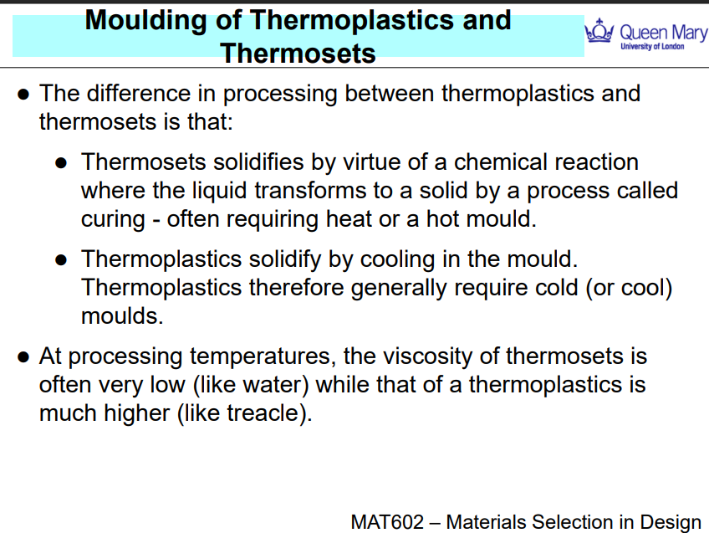
Moulding of Thermoplastics and Thermosets
- THERMOPLASTIC – heat polymer up , squeeze (mold) it into a chamber under pressure (still quite viscous)
Supplied as solid pellets

- THERMOSET – opp of thermoplastic, starts as a really low viscosity fluid, pump it into a chamber, heat up chamber – comes out as solid e.g., epoxy resin more viscous than water but less than e.g., treacle or honey
Supplied as a liquid or semi-liquid resin

INJECTION MOULDING
Injection moulding is a fast, automated process used to convert granular thermoplastic materials into complex, detailed parts. It’s widely used in mass manufacturing e.g.,
Step-by-Step Process:
- Feeding:
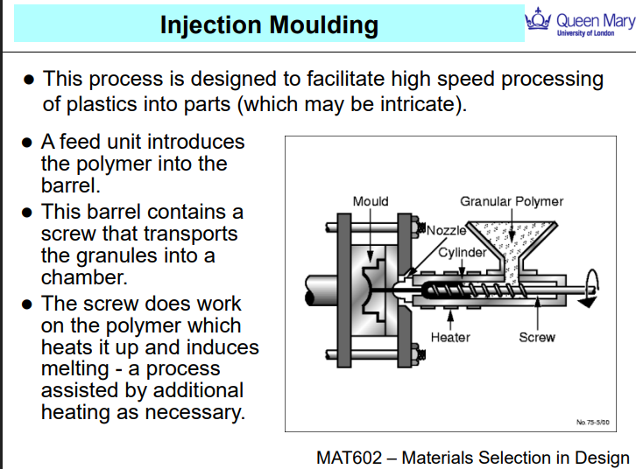
  - Plastic granules (usually thermoplastics) are loaded into a hopper.
  - They drop into a barrel with a rotating screw.
- Heating & Melting:
  - As the screw rotates, it conveys the granules forward.
  - The friction from the screw + external heaters causes the granules to melt into a viscous fluid.
- Injection:
  - Once a full shot of molten polymer is ready, the screw acts as a plunger, pushing the melt through a nozzle into the mould cavity.
- Cooling & Ejection:
  - The polymer cools and solidifies in the mould (which is kept cold).
  - The mould then opens, and the part is ejected.

Other forms of Injection Moulding
Gas-Assisted Injection Moulding
- Involves injecting gas (usually nitrogen) into the mould after the polymer.
- The gas pushes the molten plastic outward, creating hollow sections inside the part.
- Advantages:
  - Reduces material usage
  - Makes parts lighter
  - Helps produce thicker, more uniform walls
- Common in: back of TV
Co-injection moulding - mould multiple polymers into a single part
Advantages:
- Combines cost-efficiency and performance
- Useful for products needing aesthetic finish + strength
Scrim
Uses multiple injection barrels with one tool.
After filling the mould, oscillating pressure is applied before the polymer solidifies.
Advantage:
- Create preferred molecular alignment (orientation)
- Reduce voids and improve part quality
Downside: It's expensive and can damage moulds due to pressure cycling.
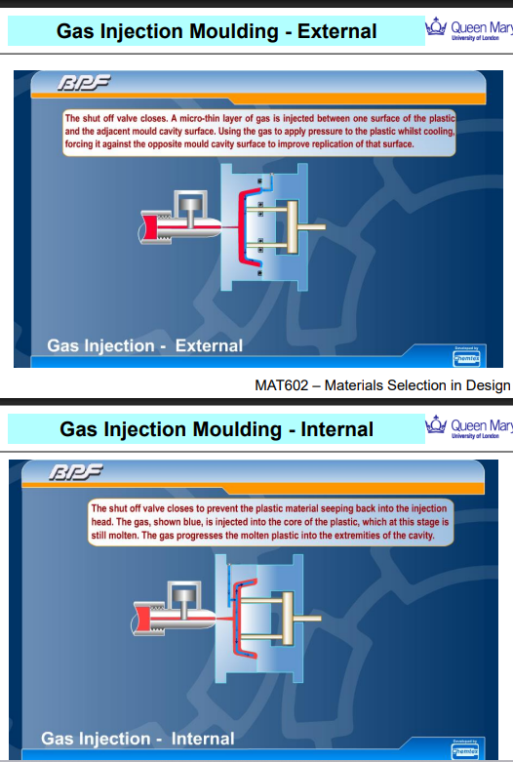
External Gas Injection Moulding: THERMOPLASTIC
- A thin layer of gas is injected between the outer surface of the molten polymer and the mould wall.
- The gas pushes the polymer tightly against the opposite mould surface.
- This helps to replicate fine surface details while maintaining hollow interiors.
Used for:
- Parts where external appearance and surface detail are important.
- Creating uniform outer surfaces with reduced material use.

Internal Gas Injection Moulding:
- The gas is injected into the core of the molten plastic, while it’s still inside the mould.
- The gas pushes the plastic outward, forcing it to fill the mould extremities.
- It also helps create hollow sections, reducing weight and material.
Used for:
- Producing hollow parts with thick sections (e.g., handles, tubes).
- Ensuring complete fill of complex geometries without sink marks.
EXTRUSION PROCESSES - thermoplastic
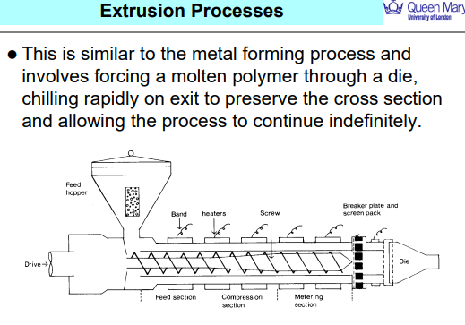
EXTRUSION - continuous polymer shaping process used to produce parts with a constant cross-section, such as pipes, tubes, window frames, and plastic sheets.

Blow Moulding - e.g. bottles
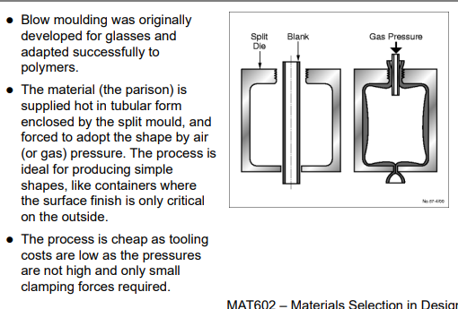
- A molten polymer tube (called a parison) is extruded vertically.
- The parison is enclosed within a split mould.
- Compressed air or gas is then blown into the parison.
- The pressure causes the polymer to expand and press against the mould walls, taking its shape.
- The plastic cools and hardens in that form.
- The mould opens and the final part is ejected

Vacuum Forming
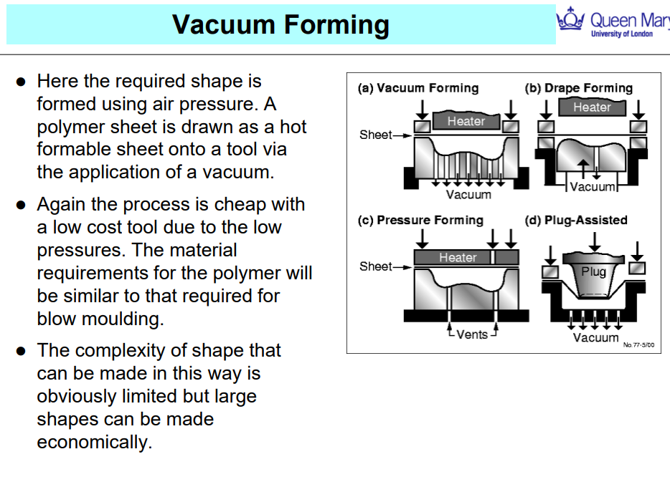
- A vacuum is applied beneath the mould, sucking the sheet into its shape.
- The sheet cools and hardens, taking on the mould’s contours.
- (a) Vacuum Forming – Basic form using suction only
- (b) Drape Forming – Sheet sags over the mould before vacuum is applied
- (c) Pressure Forming – Uses vacuum plus extra air pressure on top
- (d) Plug-Assisted Forming – A plug pushes the sheet into the mould before vacuum is applied, improving accuracy

BLOWN FILM – PLASTIC BAG

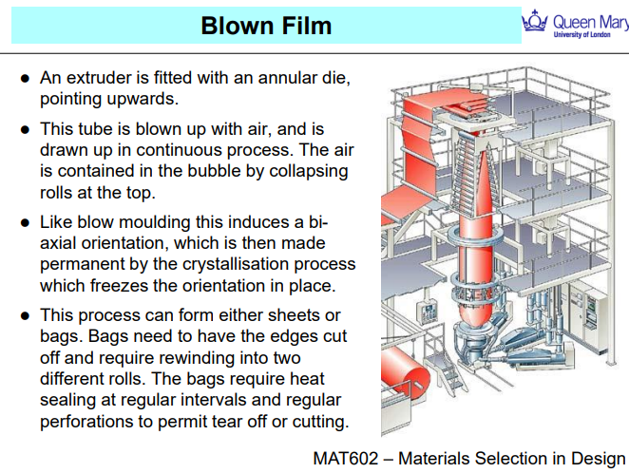

Rotational Moulding

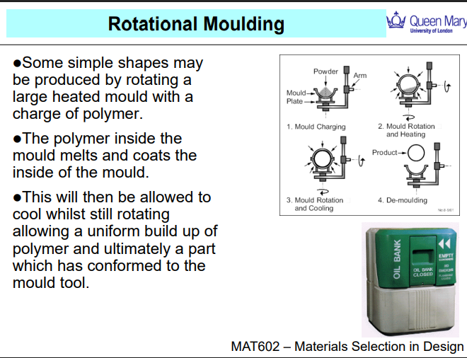
- A pre-measured amount of thermoplastic powder is placed inside a hollow metal mould.
- The mould is sealed.
- As the mould rotates, the plastic powder melts and coats the interior surface evenly.
- Powder - melted and distributed, the mould is cooled, typically by air or water mist.
- The mould is then opened, and the solidified part is removed.
e.g., water tanks, storage bins and etc.

Cost Comparison
INJECTION MOUDLING – MACHINERY EXPENSIVE BUT EASY TO PRODUCE A BATCH
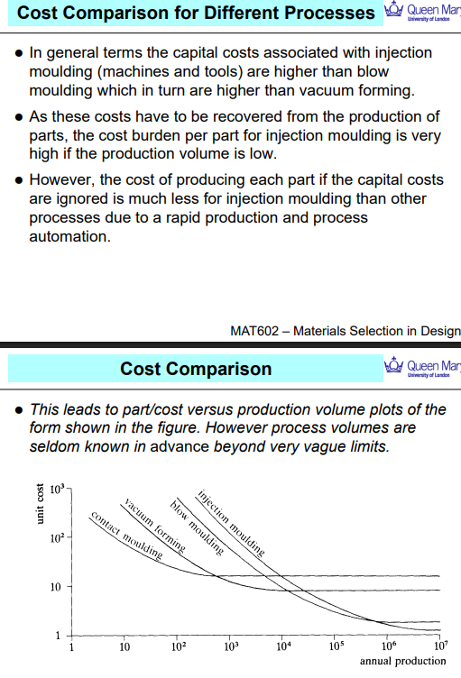



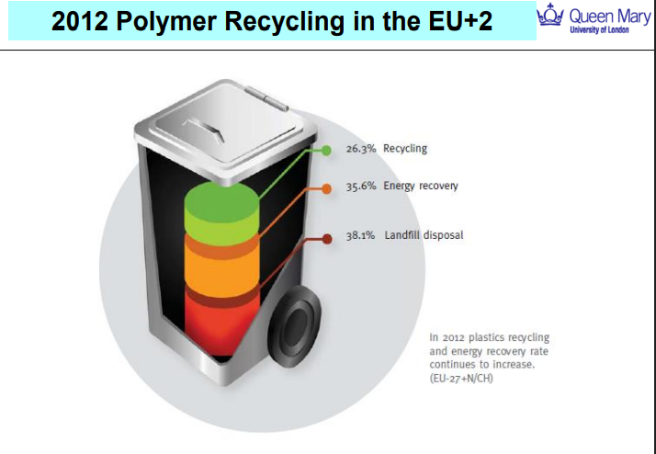

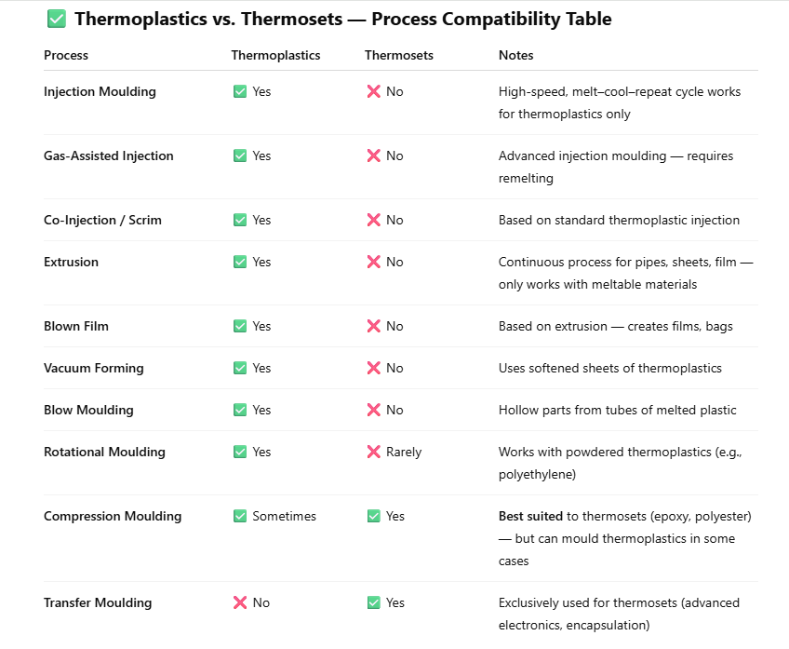

Method | Advantages | Disadvantages
Injection Moulding | High precision and repeatability  Fast cycle times for mass production  Good surface finish | High tooling cost  Limited to thermoplastics  Difficult for very large parts
Gas-Assisted Injection Moulding | Hollow parts with less material  Reduces warping and sink marks  Good for complex shapes | More complex tooling  Process control is critical  Only for thermoplastics
Extrusion | Continuous process  Excellent for long, uniform profiles  Low material waste | Limited to simple cross-sections  Surface finish may need post-processing
Blown Film Extrusion | Produces thin, biaxially oriented films  High throughput  Ideal for packaging | Limited to thin film products  Requires precise control
Blow Moulding | Great for hollow containers (e.g., bottles)  Low cost for large volumes  Good for thin-walled parts | Poor control over wall thickness  Limited to simple shapes
Vacuum Forming | Low tooling costs  Fast setup for low-volume production  Simple equipment | Limited to shallow parts  Poor detail resolution  Only one good surface
Rotational Moulding | Uniform wall thickness  Ideal for large hollow items  No seams or welds | Long cycle time  Lower detail accuracy  Not suitable for small intricate parts
Compression Moulding | Good for thermosets  Low scrap rate  Can mould large parts | Limited to simple geometries  Slower than injection moulding  Labour intensive

